IFT458&544: Middleware Prog & Database Sec

(2023 Fall)

Subject: Module 2 Assignment: JavaScript language

Aishwarya Devi Akkim

Instructor name: Dinesh Sthapit

Due date: 09/3/2023

Introduction to JavaScript - 1

JavaScript Function Refactoring 2

Code:

// function greetTheStudent(studentName){

// return `Hello there ${studentName}`;

// }

// const greetTheStudent = function (studentName){// parameter // anonymous function // expression

// return `Hello there ${studentName}`;

// }

// fat arrow function

const greetTheStudent = (studentName) => `Hello there ${studentName}`;

const studentName = 'Mary Jane';

const greet = greetTheStudent(studentName);//argument

console.log(greet);

// console.log(message+ ' ' + studentName);

// console.log(message+ ' ' + studentName2);

Output:

PS C:\458_544Assignments\Module2AssignmentJavaScriptlanguage> node index.js

Hello there Mary Jane

JavaScript Refactoring 3

Code:

// function greetTheStudent(studentName){

// return `Hello there ${studentName}`;

// }

// const greetTheStudent = function (studentName){// parameter // anonymous function // expression

// return `Hello there ${studentName}`;

// }

// fat arrow function

const greetTheStudent = (studentName) => `Hello there ${studentName}`;

const fullName = (firstName, middleName, lastName) => `${lastName}, ${middleName}. ${firstName}`;

// const studentName = 'Mary Jane';

// const greet = greetTheStudent(studentName);//argument

// console.log(greet);

const titleName = fullName('Mary', 'R', 'Jane');

console.log(titleName);

// console.log(message+ ' ' + studentName);

// console.log(message+ ' ' + studentName2);

Output:

PS C:\458_544Assignments\Module2AssignmentJavaScriptlanguage> node index.js

Jane, R. Mary

JavaScript Variable 4

Code:

var age = 10; // int

var salary = 15.00 // double

console.log(`The variable type of age is ${typeof age}`);

console.log(`The variable type of salary is ${typeof salary}`);

var name = 'John Smith';

console.log(`The variable type of name is ${typeof name}`);

const displayGreetings = function(name, year){

console.log(`Happy new year ${year} ${name}`);

}

console.log(`The variable type of displayGreetings is ${typeof displayGreetings}`);

Output:

PS C:\458_544Assignments\Module2AssignmentJavaScriptlanguage> node functionDemo1.js

The variable type of age is number

The variable type of salary is number

The variable type of name is string

The variable type of displayGreetings is function

JavaScript Object 5

Code:

var age = 10; // int

var salary = 15.00 // double

// console.log(`The variable type of age is ${typeof age}`);

// console.log(`The variable type of salary is ${typeof salary}`);

// var name = 'John Smith';

// console.log(`The variable type of name is ${typeof name}`);

const displayGreetings = function(name, year){

console.log(`Happy new year ${year} ${name}`);

}

//console.log(`The variable type of displayGreetings is ${typeof displayGreetings}`);

const displayGreetingsWithEmoji = function(name, year){

console.log(`Happy new year ${year} ${name}😊😊`);

}

var greet = {};

if(age > 10){

greet = displayGreetings;

}

else{

greet = displayGreetingsWithEmoji;

}

greet('Sam', 2022);

Output:

PS C:\458_544Assignments\Module2AssignmentJavaScriptlanguage> node functionDemo1.js

Happy new year 2022 Sam😊😊

JavaScript Parameter (Function as a parameter) 6

Code:

var age = 10; // int

var salary = 15.00 // double

// console.log(`The variable type of age is ${typeof age}`);

// console.log(`The variable type of salary is ${typeof salary}`);

// var name = 'John Smith';

// console.log(`The variable type of name is ${typeof name}`);

const displayGreetings = function(name, year){

console.log(`Happy new year ${year} ${name}`);

}

//console.log(`The variable type of displayGreetings is ${typeof displayGreetings}`);

const displayGreetingsWithEmoji = function(name, year){

console.log(`Happy new year ${year} ${name}😊😊`);

}

const greet = function(name, year,func){

func(name,year);

}

greet('Sam', 2022, displayGreetingsWithEmoji);

greet('Jane',2022,displayGreetings);

Output:

PS C:\458_544Assignments\Module2AssignmentJavaScriptlanguage> node functionDemo1.js

Happy new year 2022 Sam😊😊

Happy new year 2022 Jane

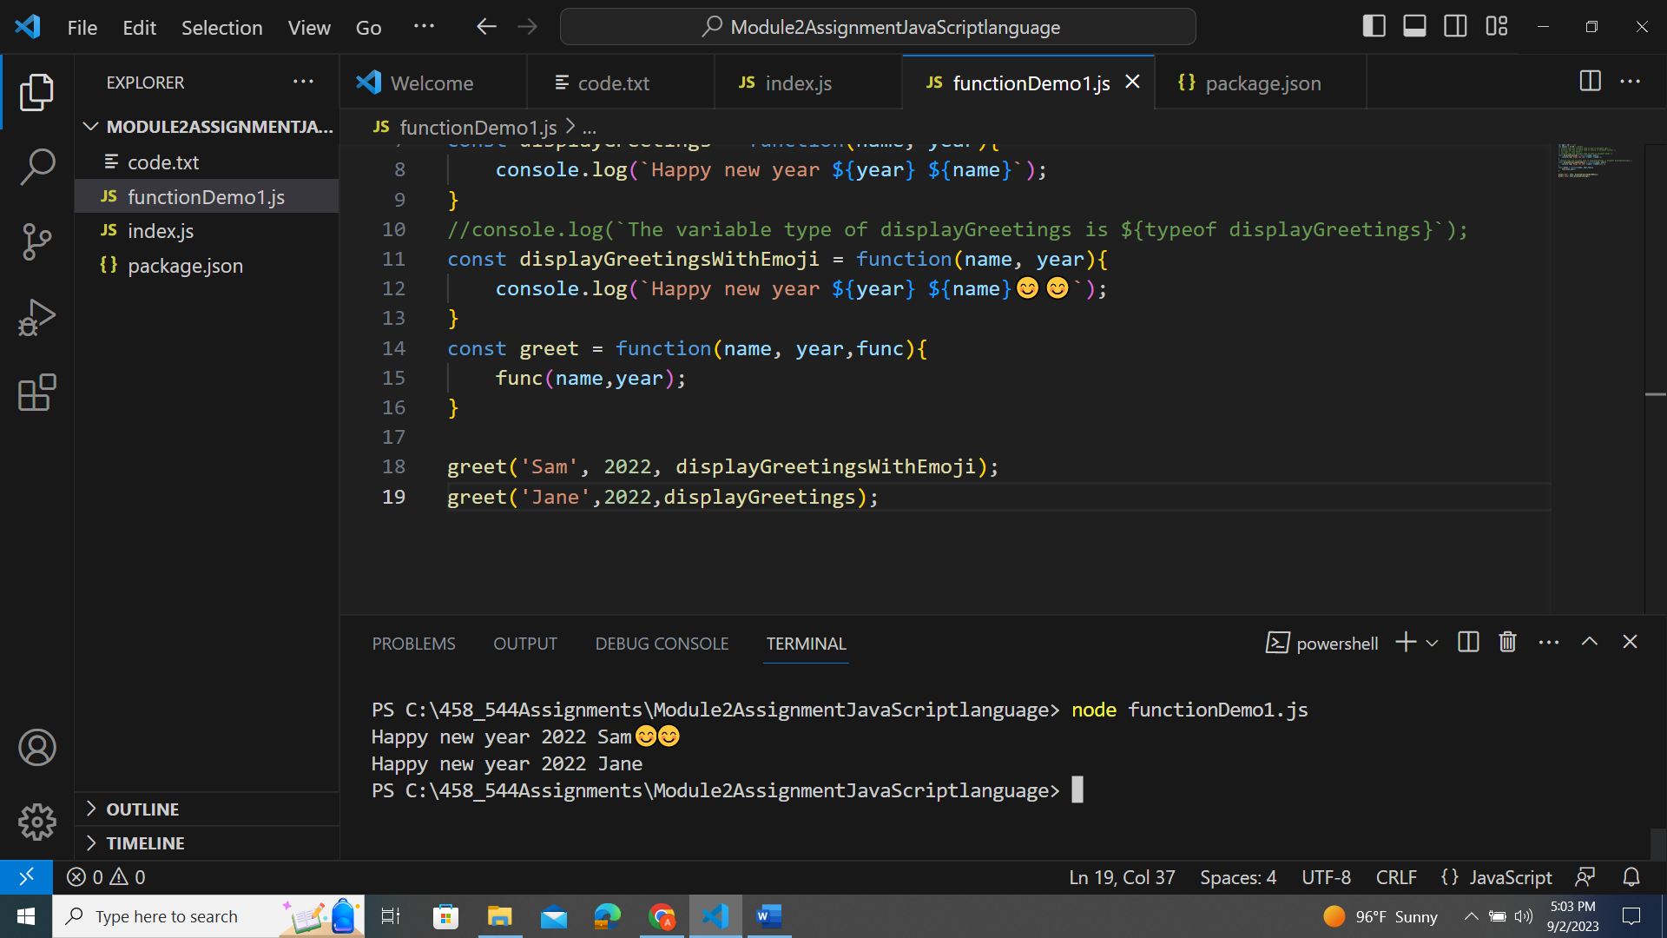

JavaScript Objects II 8

Code:

var students = ['John','Sammy','Jaime','Mike','Jane'];

// console.log(students[0]);

// console.log(students[2]);

// console.log(students.length);

var grades = [90,99,89,100,80];

// console.log(grades[0]);

// console.log(grades[2]);

console.log(grades.length);

console.log(grades[grades.length - 1]);

console.log(grades[grades.length - 2]);

Output:

PS C:\458_544Assignments\Module2AssignmentJavaScriptlanguage> node objects.js

John

Jaime

5

90

89

5

PS C:\458_544Assignments\Module2AssignmentJavaScriptlanguage> node objects.js

5

80

100

JavaScript 9

Code:

var student ={

name: 'Joan Smith',

birthYear: 2002,

course: 'IFT 458',

grade:90,

active: true,

age: function(){

return 2022 - this.birthYear;

}

}

// lambda funtion or fat arrow functions dont have acces to 'this' therefore no ouptut

var student2 ={

name: 'Andy Moore',

birthYear: 2000,

course: 'IFT 458',

grade:100,

active: false,

age: function(){

if(this.active){

return 2022 - this.birthYear;

}

else{

return 0;

}

}

}

// console.log(student['name']);

// console.log(student.name);

console.log(student2.age());

console.log(student.age());

Output:

PS C:\458_544Assignments\Module2AssignmentJavaScriptlanguage> node student.js

22

PS C:\458_544Assignments\Module2AssignmentJavaScriptlanguage> node student.js

22

20

PS C:\458_544Assignments\Module2AssignmentJavaScriptlanguage> node student.js

NaN

NaN

PS C:\458_544Assignments\Module2AssignmentJavaScriptlanguage> node student.js

0

20

JavaScript 10

Code:

var students = [];

var student ={

name: 'Joan Smith',

birthYear: 2002,

course: 'IFT 458',

grade:90,

active: true,

age: function(){

return 2022 - this.birthYear;

}

}

// lambda funtion or fat arrow functions dont have acces to 'this' therefore no ouptut

var student2 ={

name: 'Andy Moore',

birthYear: 2000,

course: 'IFT 458',

grade:100,

active: false,

age: function(){

if(this.active){

return 2022 - this.birthYear;

}

else{

return 0;

}

}

}

// console.log(student['name']);

// console.log(student.name);

students.push(student);

students.push(student2);

students.forEach((item) => console.log(item.age()));

console.log(students);

// console.log(student2.age());

// console.log(student.age());

Output:

PS C:\458_544Assignments\Module2AssignmentJavaScriptlanguage> node student.js

20

0

[

{

name: 'Joan Smith',

birthYear: 2002,

course: 'IFT 458',

grade: 90,

active: true,

age: [Function: age]

},

{

name: 'Andy Moore',

birthYear: 2000,

course: 'IFT 458',

grade: 100,

active: false,

age: [Function: age]

}

]

